**QF600 (Asset Pricing) – Homework 4**

**Efficient Frontier Revisited**

**Part 1: Minimum-Tracking-Error Frontier**

1. Let market return be the target return. Estimate expected deviation from market return, for the ten industry portfolios:

Answer:

|  |  |
| --- | --- |
| **Industry** | **Expected Deviation** |
| NoDur | 0.15475 |
| Durbl | -0.01475 |
| Manuf | 0.26475 |
| Enrgy | 0.483083 |
| HiTec | 0.018167 |
| Telcm | 0.133333 |
| Shops | 0.16825 |
| Hlth | 0.03575 |
| Utils | 0.159083 |
| Other | -0.259 |

1. Also estimate covariance matrix of return deviations, for the ten industry portfolios:

Answer:

1. Plot the minimum-tracking-error frontier generated by the ten industry portfolios:

* This graph must have expected (monthly) return deviation on the vertical axis vs (monthly) tracking error on the horizontal axis.
* This graph must cover the range from 0% to 0.1% on the vertical axis, in increments of 0.005% (or less).

Answer:

1. Also plot the line starting from the origin that is tangent to the upper half of the minimum-tracking-error frontier.

Answer:

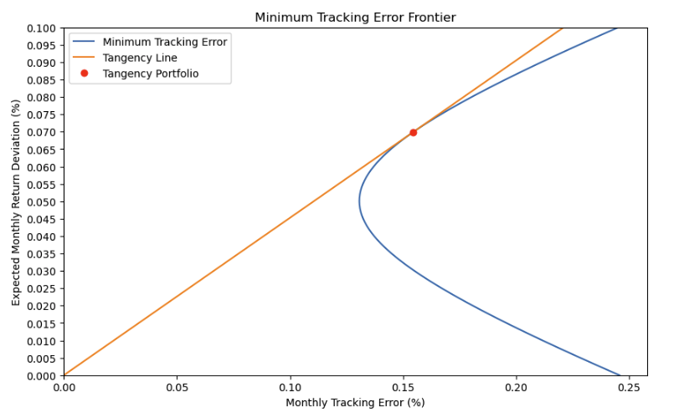

1. Calculate information ratio and portfolio weights for the "tangency" portfolio.

Answer:

Information Ratio = 0.45248753961993365

|  |  |
| --- | --- |
| **Industry** | **Portfolio Weights** |
| NoDur | 0.052634 |
| Durbl | 0.000153 |
| Manuf | 0.137627 |
| Enrgy | 0.087032 |
| HiTec | 0.179353 |
| Telcm | 0.071074 |
| Shops | 0.106884 |
| Hlth | 0.102776 |
| Utils | 0.040162 |
| Other | 0.222304 |

Part 2: Minimum-Variance Frontier w/o Short Sales

Use Monte Carlo method to simulate the minimum-variance frontier without short sales, generated by the ten industry portfolios. Portfolio weights will be limited to the range [0, 1].

Randomly draw each element of **w**, the 10 × 1 vector of portfolio weights, from the (standard) uniform distribution in the range [0, 1]. Divide **w** by the sum of portfolio weights, to ensure that the portfolio weights sum to one. This normalised **w** represents portfolio weights for one simulated portfolio, without short sales.

Use the normalised **w** along with the vector of mean returns and the covariance matrix of returns (for the ten industry portfolios) to calculate the mean return and standard deviation of return for the simulated portfolio. Repeat this process until you have (at least) 105 data points.

1. Plot the data points with mean return on the vertical axis vs standard deviation of return on the horizontal axis.

Answer:

Repeat this entire process by simulating 1/w using the standard uniform distribution ⇒ take the reciprocal of the random draw from the standard uniform distribution as the portfolio weight.

1. Plot the new data points (on a separate graph) with mean return on the vertical axis vs standard deviation of return on the horizontal axis.

Answer:

